

Efudex/Carac/Solaraze/Fluorouracil Therapy

- You have been prescribed a topical chemotherapy product used to destroy sun-damaged cells. It does not usually affect normal skin cells. The full course of treatment is necessary to eliminate most of the abnormal cells. Only use this medication under the direct supervision of your physician, only on the lesions where you are instructed to apply it and only for the time period instructed by your physician.

- Using your fingertips or a Q-tip, rub in a very thin amount of the medication. To apply to an isolated lesion apply it to the lesion and the surrounding area (about the size of a quarter). For multiple lesions in an area, apply the medication to the entire area, not just the individual spots. This method will help eliminate any small lesions that may not be visible.

- Avoid using the medication around the eyes or creases around the mouth or nose.

- Do not use this medication if you are pregnant, trying to conceive or are breastfeeding.

- This medication is preferably used in the winter. If it is used in the summer, avoid sun exposure until the areas heal. Wear at least a #30 SPF sun block if you must be in the sun at all.

- The treated areas may initially look worse with redness and peeling. It may occasionally blister and then form a crust. If you have facial swelling, oozing/drainage, or significant discomfort, please make an appointment. We would like to evaluate you as soon as possible.

- For excessive irritation, try Vaseline or Aquaphor ointment twice daily. If these measures fail, try over the counter hydrocortisone ointment. Cool compresses may also be helpful.

- Use a mild soap such as Cetaphil cleanser or Dove sensitive skin formula while on this therapy.

- Do not use Retin A, Renova, or glycolic products while on this therapy.

- Notify us at 919-781-1050 and start Valtrex or Zovirax if a fever blister (cold sore) develops.

- After completion of your therapy, the treated areas will heal in 3-6 weeks. Some redness may persist, but this usually fades. Daily sunscreen is recommended. (For the face, consider EltaMd SPF 41 (water resistant) tinted, Revision Intellishade Matte (oily skin) Tinted Aging Moisturizer SPF 45, Revision Intellishade Original (dry skin) Tinted Anti-Aging Moisturizer SPF 45, Avene Compact 100% Mineral (sensitive/intolerant skin) SPF 50. If you are interested these products are available through our office.)

Do not use this medication on any areas that have not been recently evaluated by your physician.

___Solaraze: Use twice daily for 3 months

___Efudex/Carac/Fluorouracil:

__Use every morning and night on:
face/neck/ears/chest/arms/hands/legs/scalp
for _____weeks.

___Use only at night on:
face/neck/ears/chest/arms/hands/legs/scalp
for _____weeks.

___Use at night one week of each month on:
face/neck/ears/chest/arms/hands/legs/scalp
for _____months.

Visits include:

Initial visit
- To discuss therapy protocol

1st follow up visit: In ____ days/wks/months
Office

(Please continue the cream for the entire _____days/wks/mos
unless specifically instructed to discontinue by your physician.)

Additional follow up visits will be determined at your next visit

Final visit:
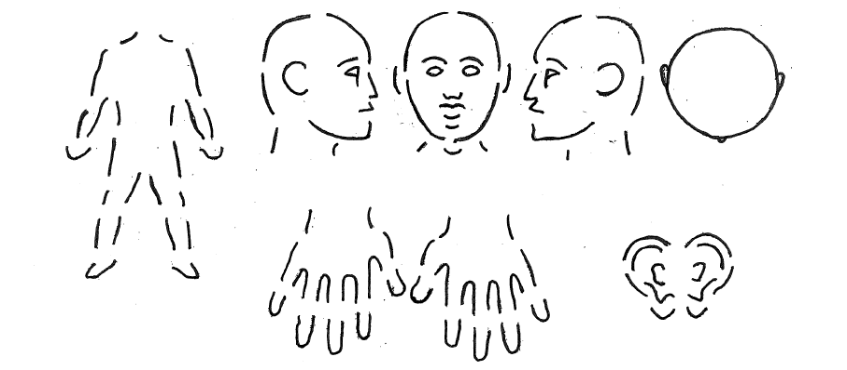
- 2 months after you have completed therapy. This visit is to determine the effectiveness of your therapy (any residual lesions may be treated with liquid nitrogen at this time).

